**Building**

***More Thoughtful***

***Public Transportation Solutions***

**with TDRO**

**____________________________________**

Anne Mercado

Civic Analytics and Urban Intelligence

December 17, 2023

**Table of Contents**

Executive Summary 3

Background 3

Introduction 5

Target Organization 6

Current Approach 6

Organization and Equity Assessment 7

*Strengths:* 7

*Weaknesses:* 8

Problem Assessment 8

Proposed Solution 9

*How It Works* 9

*Implementation Plan* 10

*Feasibility of the Proposed Solution* 11

*Possible Limitations* 12

*Possible Partnerships* 12

Conclusion 12

Next Steps 13

References 14

# Executive Summary

Public transportation in the Philippines has been a hot topic in 2023 due to the push of the government and its implementation challenges to modernize the country’s multiple modes of transportation, including one of its culture staples, the jeepney. According to the Land Transportation Franchising Regulatory Board, the PUV Modernization Program aims to give a comfortable life for all Filipinos through providing safer, more efficient, reliable, convenient, affordable, climate-friendly, and environmentally sustainable transportation system in the country. It’s a promising program by its definition as it includes the following components – regulatory reform, local government route planning, route rationalization, fleet modernization, industry consolidation, financing, vehicle useful life program, training, initial implementation and information dissemination. As big of a project it is to overhaul the country’s public transportation, the digitization of the data collection process still seems to be left out and not prioritized to be included. This means that even after a successful implementation of the project, data collection to support projects to sustain the primary program will remain manual. Hence to address this problem, this paper proposes a solution that would lead to data driven public transportation solutions that Batangas City, specifically the Transportation Department Regulatory Office, can adopt. This paper proposes PARA, an app that will serve as a platform for hailing jeepneys and tricycles, route guidance for PUV operators, and real time commuter and PUV operators data collection. This solution aims reimagine the process of public transportation data collection towards more thoughtful projects in Batangas City.

# Background

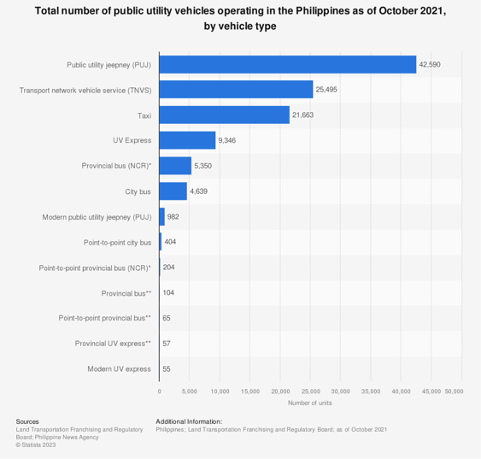Because of its archipelagic land structure, the Philippines’ public transportation varies significantly to other countries especially the developed ones. The modes of transportation of a day-to-day commuter varies from metros, jeepneys, tricycles, buses, utility vehicles, motorcycles, taxis and boats, with jeepneys, as seen in figure 1, being the top public utility vehicle operating in the Philippines as of October 2021. (Statista, 2021)

*Figure 1. Total Number of PUV operating in the Philippines per Vehicle Type (October 2021)*

Although all privately owned, except for the trains, land based public transportation are being regulated by the Land Transportation Franchising Regulatory Board in the country and by the local government for each municipality. Regulation includes mainly the routes of service, permits, licenses, fares and rates to mention a few. This specific setup may be one of the factors that cause the Philippines to lag neighboring countries in terms of public transportation progression which can then have a ripple effect towards overall urban performance.

As with all the cities in the country, Batangas City has the same landscape when it comes to public transportation with jeepneys and tricycles as the main modes of transportation especially locally. Figure 2 shows the different jeepney route network in the whole of Batangas City and the routes in each network. One must take note as well that as seen in figure 3, most of the routes do not have specified stops where the commuters can hail them. Jeepneys and tricycles alike, if they are not in terminal, are hailed on demand anywhere within its assigned route. For the entire Batangas City, all are being regulated by the Transportation Department and Regulatory Office.

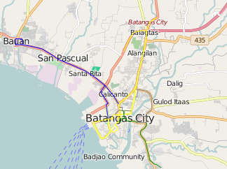

*Figure 2. Jeepney Routes in*

*Batangas City*

*(OpenStreetMap Wiki, n.d.)*

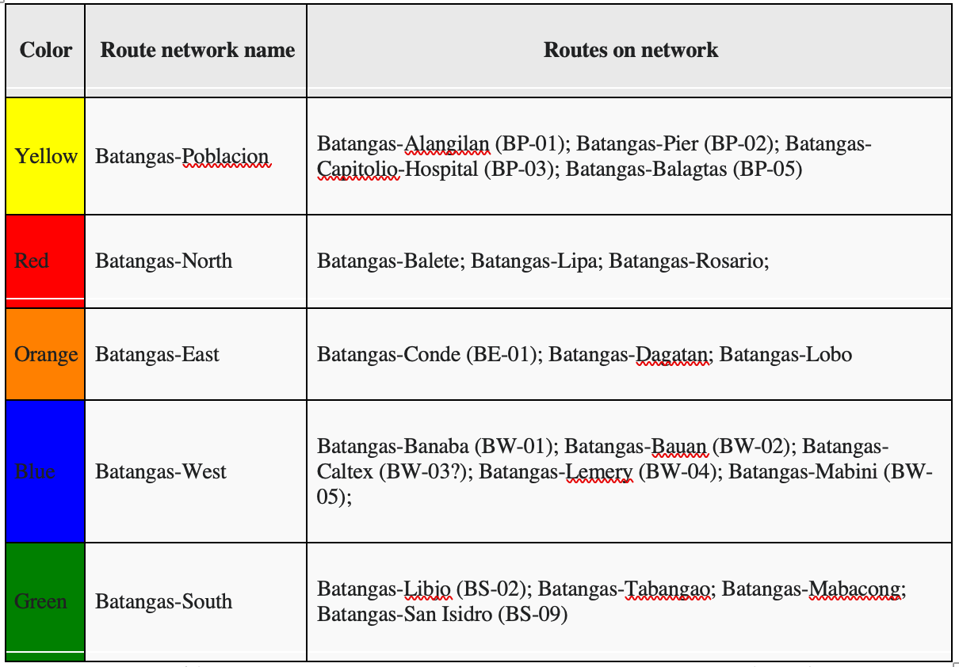

*Figure 3. Batangas City Jeepney Routes (OpenStreetMap Wiki, n.d.*

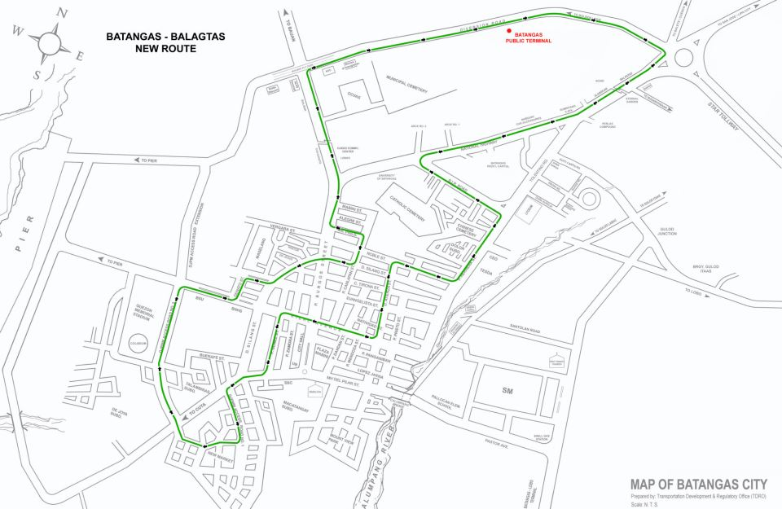

*Figure 4. Batangas-Balagtas New Route (TDRO)*

# Introduction

The Transportation Development Regulatory Office (TDRO) is a branch of the Batangas City government. It is bounded by the Batangas City Traffic Ordinance of 2000 and Batangas City Tricycle Franchising Ordinance to supervise and administer the operation and maintenance of all public land transportation vehicles. TDRO’s scope of work includes ensuring implementation of traffic rules and provide efficient transport management schemes.

*Figure 5. Batangas City Government Organization Chart*

# Target Organization

The Transportation Development Regulatory Office (TDRO) is a branch of the Batangas City government. TDRO’s scope of work includes ensuring implementation of traffic rules and provide efficient transport management schemes.

*Figure 6. Transportation Development Regulatory Office Organization Chart*

*(Banaag, CM, 2023)*

The department handles different kinds of data, as mentioned during my interview by Cris Mark Banaag, the Head of Traffic Operations and Maintenance Section. Such data include, vehicle accidents, mayor’s permit for public transportation, surveys and traffic reporting including traffic congestion. In terms of scope of work, Banaag reiterated during our conversation that TDRO mainly executes the already created traffic city ordinance. Sangguniang Panglungsod or the legislative assembly of the city oversees pushing policy changes. He did mention, such policy changes regarding traffic regulation are advised by TDRO.

# Current Approach

Banaag explained during our interview how department collect and process their data. Operations data are being supplied by both the Traffic Operations and Maintenance Section and Tricycle Franchising Permits and License Section, but all their data are being managed by the Planning, Research and Administrative Section. Operations data include apprehensions, flow of traffic and customer feedback. Permits and License Section provides the registration and licensing data of the PUV operators. Additional data of the department are internal data such as individual and team performance rating which falls under the responsibility of the Administrative Section.

The tools being used by the department varies on the data that need to be captured. For operations data to get the flow of traffic information, there are people assigned to manually monitor the flow of traffic through CCTV footage capture by cameras on major roads in the city. This is where they get the traffic status that they report in their Facebook page as seen in figures 6 and 7. Apprehensions are from traffic aid officer’s record of tickets and reports through two-way radio given each day of field work. Customer or citizen’s feedback vary depending on the platform. It can either come from the department’s Facebook page, hotline and surveys that they do.

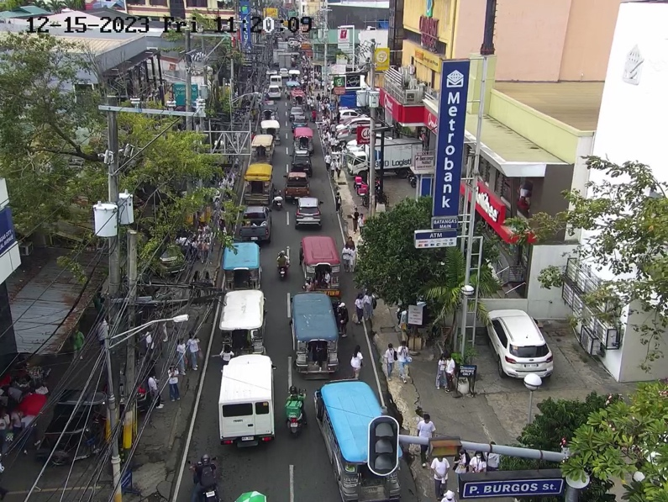

*Figure 7. TDRO Traffic Update (TDRO Facebook Page)*

# Organization and Equity Assessment

If the question is plainly asking if the processes and tools are working, Banaag said yes, they are. However, he also agreed that these are not the most efficient way of capturing information that they need.

## ***Strengths:***

* A characteristic of a strong organization if having defined roles and responsibilities and limiting the gray are in their scope of work. This is displayed in the **definitive allocation of work within each section of the department.**
* In the recent years, TDRO was able to project an **open mindset externally in terms of changes and solutions**. From 2021 – 2022, TDRO was active in replanning the routes, jeepney stops and parking areas to better accommodate the city. Compared to years before that, there was no significant changes done by the department and a lot was kept at status quo.
* **Accessibility of platforms for customers or citizens** through Facebook, department hotline or physically going to their department.
* **Collaboration with stakeholders** especially the jeepney and tricycle cooperative and operators. When it comes to changes, Banaag discussed their process in collaborating with jeepney cooperatives with regards to changes such as rerouting, change in demand and supply to name the few. Such process involves relaying results from commuter surveys or analysis of operational data.

## ***Weaknesses:***

* **Tools and platforms** used, as agreed by Banaag, **are not the most efficient** way to gather the data necessary for the department. Manual monitoring can take time to analyze and generate insights from depending on the resources available. This can affect the data that should be readily available.
* **Requesting data from the department is still a struggle**, despite its structure and system in place mentioned during the interview. It can take up to 2 months to request data that was said to be readily available as part of the department’s duties. Unfortunately, this is also the case in requests on the national level, it can take time for the departments in charge to get back with the requests. Despite having launched the Open Data in January 2014, almost 10 years ago, majority of the departments and local governments have not transition to the initiative.
* **Surveys are done irregularly**. The last survey according to Banaag was done 2019 to capture commuter’s data. To a
* **Trainings are needed** for resources assigned in answering customer’s feedback and requests. Having the platforms is one thing, execution is another. Some citizens report that personnel assigned to the platforms such as the Facebook page can sometimes be nonresponsive or have insufficient knowledge of a certain traffic or transportation matter.

# Problem Assessment

Based on the organization and equity assessment of the department, we can summarize the issues in 3 categories. First, manual data collection process. From operational data to surveys, all methods used by the department are manual hence resulting to inefficient data gathering and generation of analysis and insights. As a result, second, solutions implemented are both reactive and non-data driven. The department may have experience and prior knowledge about their systems and processes, but data driven decisions and projects have been proven, in general, to increase revenue, reduce costs, create new opportunities and enhance customer experience. (Pragmatic Institute, 2022).

Lastly, customers, in this context both the general citizens and commuters, are not satisfied with both how the department with regards to customer relation and solution implementation.

# Proposed Solution

To capture real time commuter and transport provide data, a monitoring system aims to provide another platform for the commuters to provide information instantaneously that would be visible to not just the department and the city government but also the public that would help provide transparency on the current traffic situation. As a solution, I propose, “PARA”, a jeepney and tricycle “hailing” application. Using the concept of digital ride hailing such as Uber, Lyft and Grab in Asia, commuters, jeepney and tricycle drivers will have a bird-eye perspective of the current traffic and commuting situation within a certain area.

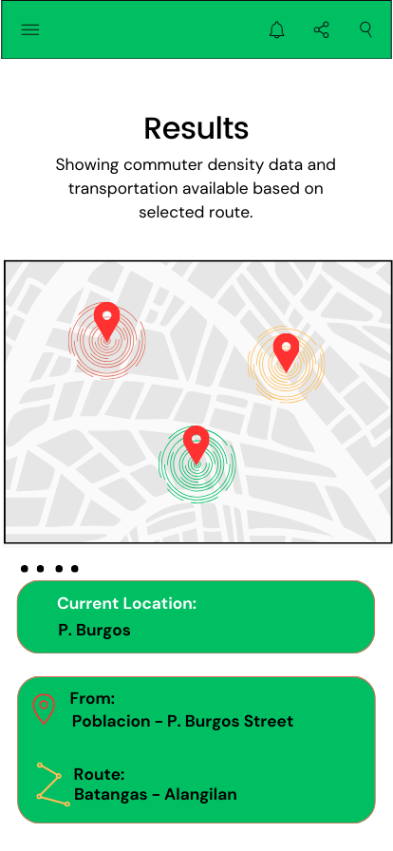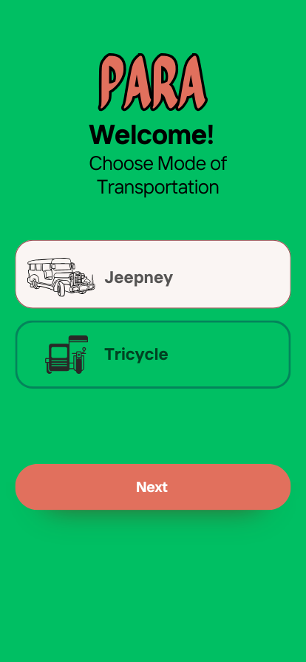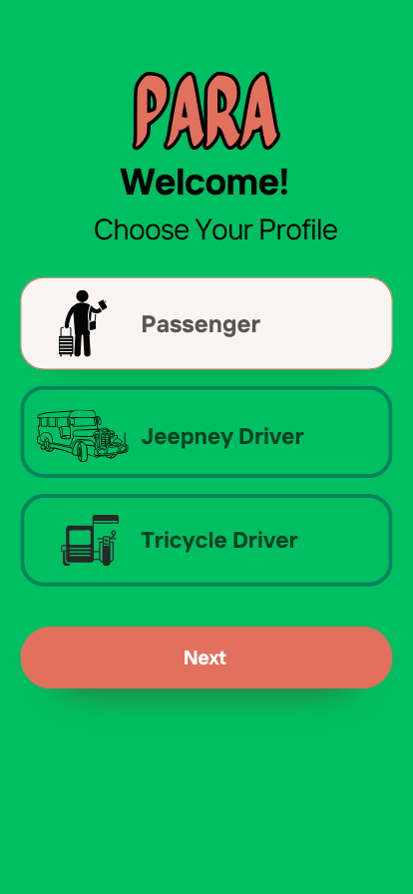

*Figures 8-10. PARA App Mock-up*

## ***How It Works***

* Commuters
  + They will be able to hail a jeepney or tricycle by sending signals through the app that would indicate the vicinity and the time they are hailing public transportation as seen in the mock-up in figures 8-10.
* Jeepney/Tricycle Drivers
  + Transport drivers would then have a view in the app of the density of commuters in a certain area as well as density of transport providers in that vicinity. They will be able to plan and strategize where will be the optimal area to pick-up passengers.
* TDRO
  + Through the linked dashboard, TDRO would get the overall view of the data captured in the app based on the metrics such as peak hour, density, heatmap of commuters as seen in figure 11.
  + As a result, learn the deep dive of the current supply and demand of public transportation in the city.

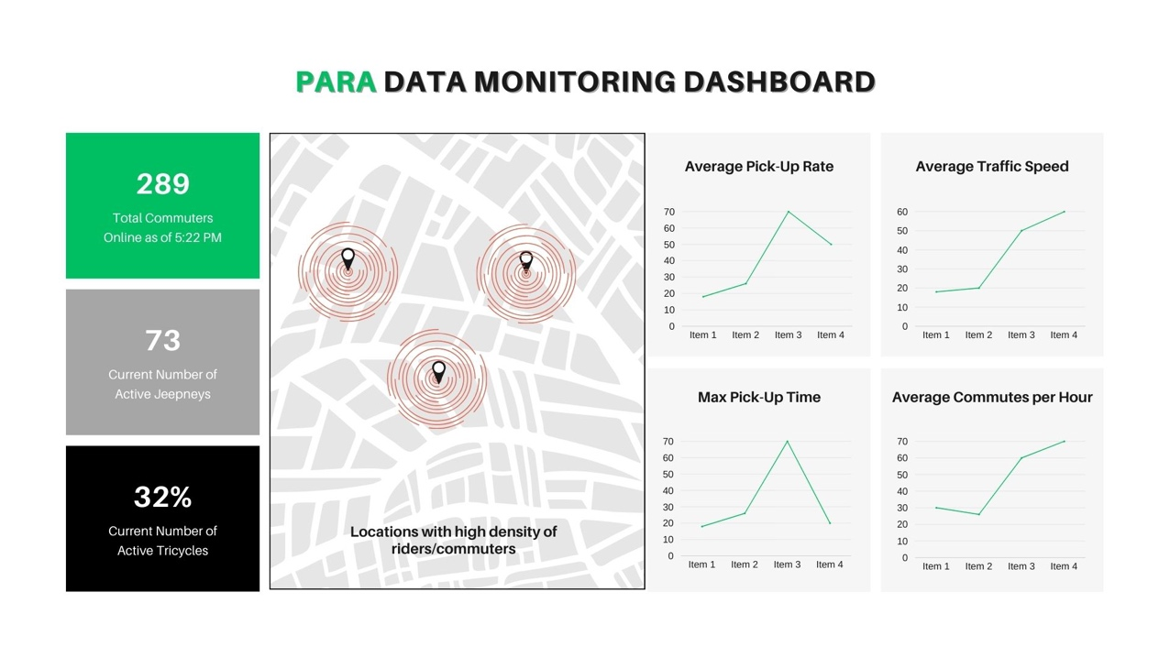

*Figure 11. PARA Dashboard Mock-up*

## ***Implementation Plan***

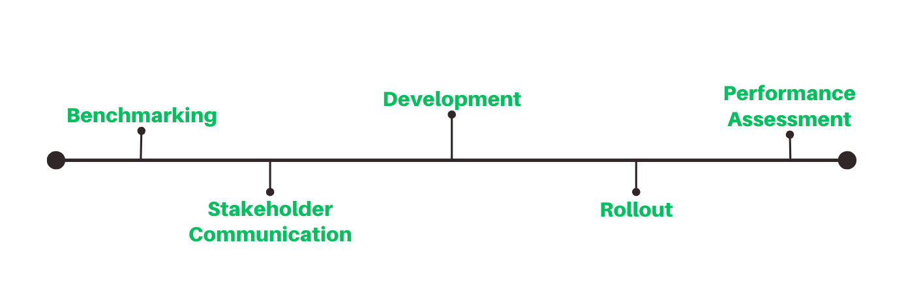Implementation and roll-out of such solution is not as straightforward as developing the app and rolling it out for the users to basically use. Below is the implementation milestone that will be followed to ensure the success of the initial rollout of the app.

*Figure 12. PARA Project Implementation Milestone*

1. *Benchmarking (0 - 6 months)*
   1. Studying the current approach especially the process and KPIs
   2. This would involve TDRO as a department to get a hold of their current data collection process and scores on the metrics that would be in scope.
   3. This will be the basis of any changes in the processes with the adoption of the technology.
2. *Stakeholder Communication (All throughout the process, even after rollout.)*
   1. Communication the changes to all stakeholders. This includes the local government, commuters, jeepney and tricycle operators, LTFRB and other departments that may have dependencies or will be impacted by the rollout.
3. *Development (6 – 15 months)*
   1. This would include the matching and mapping of the already known technology such as Grab’s ride hailing app and molding it to fit the public transportation landscape.
   2. This would also include the actual development and testing of the technology.
   3. This is an opportunity for the department to collaborate with partners like Grab as the main ride hailing app in the country if they haven’t done so.
4. *Roll-Out (15th month)*
   1. Rolling out of the technology to the general masses and all the identified stakeholders
5. *Performance Assessment (15 month onwards)*
   1. Continuous monitoring and measurement of the performance of the technology as to ensure successful fit to the need of the stakeholders.
   2. From this stage, possible deltas can come up for future updates.

## ***Feasibility of the Proposed Solution***

According to Batangas City’s Annual Budget Report for 2021 and 2022, there was a 350% increase in budget in Information & Communication Tech. Equipment in just one year. Although this may be allocated to multiple departments, the increase of budget for technology looks promising not just for the department but for the city in general.

Support wise for the technology, internally, the local government has an established Information Technology Division that currently supports the government activities. Although there might be a need for additional resources during and after implementation, increasing headcount would be less of work as compared to creating the team from scratch.

Similarly, in TDRO itself, the current structure including definitive roles and centralized data management in the organization provides a strong foundation in the adoption of technology.

## ***Possible Limitations***

1. *Privacy Concerns* – As this is considering the location and mobility of the citizens this can raise privacy concerns from the citizens if not securely protected.
2. *Data Security* - As with any data, data breaches and unauthorize access is a risk for this kind of solution. This could lead to a possible misuse of data as an example.
3. *Financial Investment* – Even though the government has shown positive outlook in investing to technologies, budget for this kind of technology needs to be evaluated thoroughly.
4. *Public Resistance* – Some commuters may not like being monitored and this can lead to not having an effective solution.
5. *Insufficient Data and Technology Foundational Knowledge –* Some members from the department face a steep learning curve during training and implementation of the solution.

## ***Possible Partnerships***

* 1. *Private Sector* – The department can partner and collaborate with tech companies like Grab Philippines or new startups in the development, roll-out and support management after the implementation.
  2. *Educational Institutions* – TDRO can partner with Batangas State University as well in terms of data analysis and generating insights.

# Conclusion

Based on the assessment done on the department, I believe TDRO has the capacity for the upgrade their technology in digitizing data collection of the department. Although with gaps, as with any other organization looking to upgrade, the department has proven to have a strong foundation to add what is needed to close those mentioned gaps. Below are some recommendations to fully equip TDRO for the adoption of this data driven solution.

1. ***Current Organization*** ***Structure***
   1. Continue creating a culture that is aware of the department’s common goal. To be aware of the vision and the goal of the department, each member of that department will have clarity on what’s his specific role and what he or she should be doing.
   2. Training and retraining of member of the department – this would aid not just the member themselves but also the stakeholders who also aim to learn about the traffic situation in Batangas City
2. ***Stakeholders/Partners and Citizens***
   1. Nurture the culture of having open communication not just internally but with all the stakeholders. This opens the doors to better collaboration from different perspective of the issue.
   2. Create more external partnerships with the private sectors may it be educational institution, corporation or an NGO. This enhances the collaborative effort of the department providing even more perspective to what they do.
3. ***Current Organization Outcomes***
   1. Continue the progressive mindset in the department. This has shown to work in the recent years through the significant changes being done in the operations.
   2. Collaborate with different partners to further increase the progression in the transportation realm.

A data driven solution equates to proving more thoughtful solutions, not just for the city’s public transportation, but overall. This solution can set the tone for the whole city of Batangas when it comes to data driven decision making and project implementation.

# Next Steps

1. Allocate a core project team that would ensure be focused on the delivery of all tasks in the project. This ensures that the plan and project is a priority for the department.
2. Initial communication with all the stakeholders – set expectations with all the stakeholders what the department needs from them and what will be delivered to them.
   1. Initial communication with identified possible partnerships. Communicate with them the plan and get their inputs and insights for better implementation of the solution.

# References

1. *Philippine Statistics Authority*. eFOI - Electronic Freedom of Information. (n.d.). https://www.foi.gov.ph/requests/aglzfmVmb2ktcGhyHQsSB0NvbnRlbnQiEFBTQS0zMTE4NzI2NTcwMjAM
2. *Briefing Paper for PUV modernization program - otc.gov.ph*. LTFRB - PUV Modernization Program. (n.d.). <https://otc.gov.ph/wp-content/uploads/2020/12/PUVMP.pdf>
3. *Philippines - Transport infrastructure*. (n.d.). International Trade Administration | Trade.gov. <https://www.trade.gov/country-commercial-guides/philippines-transport-infrastructure>
4. *Statista*. (2021, October). Statista. Retrieved December 15, 2023, from <https://www-statista-com.proxy.library.nyu.edu/statistics/1268623/philippines-number-of-puvs-operating-by-vehicle-type/>
5. Han, L., Peng, C., & Xu, Z. (2022, December 29). *The effect of commuting time on quality of life: Evidence from China*. International journal of environmental research and public health. <https://www.ncbi.nlm.nih.gov/pmc/articles/PMC9819363/>
6. *OpenStreetMap Wiki - User:TagaSanPedroAko/Public Transport/Jeepney routes -*. (n.d.). Open Street Map. <https://wiki.openstreetmap.org/wiki/User:TagaSanPedroAko/Public_Transport/Jeepney_routes>
7. *TDRO*. Batangas City Official Website - Transportation Development Regulatory Office. (n.d.). https://www.batangascity.gov.ph/web/tdro
8. *Open data (PH0031)*. Open Government Partnership. (n.d.). https://www.opengovpartnership.org/members/philippines/commitments/PH0031/#:~:text=The%20Open%20Data%20Portal%20(www,which%20are%20in%20open%20format.
9. *Top 4 advantages of data-driven decision making*. Pragmatic Institute Resources. (2023, May 23). <https://www.pragmaticinstitute.com/resources/articles/data/four-key-benefits-of-data-driven-decision-making/>
10. Annual gad accomplishment report, FY 2022 - Batangas City. (n.d.-b). https://www.batangascity.gov.ph/web/images/FDR/2022/AnnualGAD2022.pdf